Always Great Ideas for Katie Nolan

*I know there are more than five headline/punchline jokes and one more segment pitch than was requested, so if out of fairness you can’t look at such additional work, hopefully you can just ignore the extras. Either way, I wasn’t trying to disregard the guidelines. I had a lot of fun with this and simply had extra ideas that I thought would help paint the best picture of myself. Thank you for your time and attention.

Headline/Punchline Jokes

- All the Pretty Horses: Tim Tebow Completes Prophesied Journey from Broncos Starting QB to Rumble Ponies All-Star
- Roger Goodell Praises Bucs’ QB Winston for Not Deflating Uber Driver’s Tires
- Wizards Fans Ecstatic to Land Austin Rivers, Trey Burke’s Long Sought Successor
- World Cup Trophy Can’t Wait to Hit Puberty, Blossom Into Stanley Cup
- Love & Other Cavs: Wrong Kevin Poised to Land His Own Team
- FIFA to Replace Fair Play Tiebreaker with Game of Go Fish
- Germany-Shaped Piñatas Take Mexico By Storm
- Sam Presti spotted in park reading H.G. Wells’ The Time Machine
- Tigers’ Pitching Coach Fired for Racial Slur, Says He’ll Run for Political Office
- LeBron Calls Durant to Discuss Having Finally Watched La La Land

3 Minute Monologue (approximately)

Zabivaka and the Russian Goggle Conspiracy

Who will win the World Cup?

While we anxiously await that answer, let’s discuss an anthropomorphic wolf.

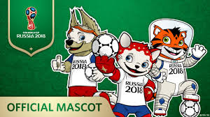
If you weren’t aware, the 2018 World Cup has a mascot. Yes, an anthropomorphic wolf named Zabivaka, who won the honor via internet vote over a cosmonaut tiger and a cat, the latter of which, as you can see, is best described as a sentient demon strawberry equipped with state-of-the-art goalie gloves in order to snatch the souls of unsuspecting children from all 32 participating nations.

Seriously, look at that thing. That is not a cat. Not even when I’m drunk.

But, assuming for a moment that this devil creature is in fact a cat, why were two of the three voting options a tiger and a cat? A tiger is a cat. Russia, where is the animal diversity here?

Perhaps that redundancy is why the wolf won, with the tiger and cat splitting precious feline enthusiast votes.

Regardless, I think the fans got it right with this cute prepubescent wolf. He’s even got nerdy soccer goggles, a nice touch that appeals to the growing generation of kids who aspire to look just like Edgar Davids.

Wait, kids don’t want to look like Edgar Davids? Kids don’t know who Edgar Davids is? Are you kidding me? He’s freaking Edgar ‘Goggle Man’ Davids!

Kids, you’re breaking my heart.

While Edgar Davids wore goggles to protect his eyes after glaucoma surgery, Zabivaka’s goggles serve a slightly different purpose.

According to Zabivaka’s designer, ‘Zabivaka is so fast on the field that he needs eye protection.’ That might sound ridiculous, but, according to research, it’s scientifically sound. Cyclists wear goggles and, according to the average top speed of cyclists, wolves can run faster.

Duh. Everyone knows that.

So kudos to student designer Ekaterina Bocharova for the realistic design. There’s no way I could have gotten on board with a goggle-less soccer playing wolf. That’s asking too much of my imagination. Nope. Can’t make that imaginative leap.

Naturally, the goggles got me thinking about Washington Wizards forward Otto Porter, and because I was disappointed in my brain for jumping first to Otto Porter, I thought about actually relevant athletes who once wore goggles, such as Eric Dickerson, Kareem Abdul-Jabbar, and, perhaps too obviously, Michael Phelps. With all due respect to all of these and other goggle-wearing athletes, I wasn’t convinced any of them could outrun, let alone outswim, a professional cyclist. Unless we’re forcing that cyclist to pedal through a swimming pool. Then I’m all in on Phelps, maybe even Otto.

My point is, it struck me, thanks to Otto – who, you’re welcome, Otto Porter, you’re now relevant in a World Cup discussion, even if you’ll never be relevant in an NBA discussion – there has to be another reason why this wolf is wearing goggles.

And I figured it out! In a surprising twist, the goggles aren’t to help the wolf’s eyesight.

Oh no, ladies and gentlemen. What we have on our hands is another Russian athletic scandal.

If you go to mascot.fifa.com, you can watch a short video showcasing Zabivaka’s awesome soccer skills. Except that his soccer skills aren’t awesome. They’re lies.

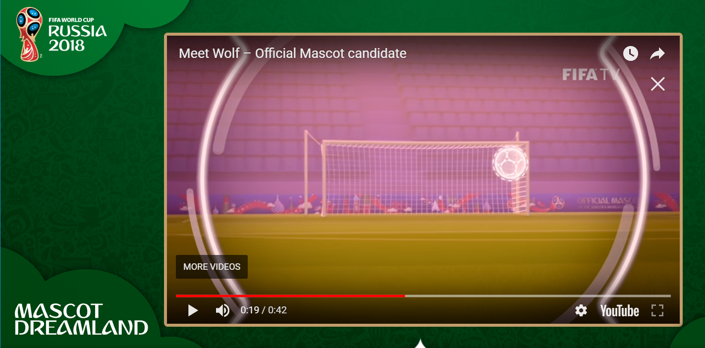
In the video, when Zabivaka is about to shoot, the camera zooms into a first-person point of view, so we see what he’s seeing, and it is very clear that Zabivaka’s goggles allow him to auto-target the perfect top right corner shot.

Russia, you brilliant cheating bastards. Just when we thought, ‘there’s no possible way the Russians would try to cheat at something again,’ bam! There it is. Russia cheats at mascots.

In Russia’s defense, it’s not like they’ve equipped their entire World Cup squad with auto-targeting goggles. No, because Russia always gets caught, but never that easily, which leads me to believe that their players must be wearing auto-targeting contacts.

Wait, you know what, pump the brakes. I don’t have any factual basis for that claim. I shouldn’t spark a controversy based on video evidence of a cartoon soccer playing wolf. Besides, if the Russians were cheating, there is no way they would have allowed themselves to play a team as good as Spain in their first elimination match. Unless they beat Spain…

Look, the truth is this: Zabivaka is cute, and he was the right choice for Russia 2018, especially if you hate cats and/or demonic strawberries, but as a self-respecting soccer fan who, just like FIFA, aspires to uphold only the highest standards for the game and the integrity with which it’s played (stifles laugh), I cannot in good conscience support Zabivaka until he owns up to his cheating ways and starts wearing goggles that do nothing more than provide a needed prescription and protect his adorable soccer balls of eyes.

Segment Ideas

Segment Pitch #1: In Relief

Every day, athletes go out and work to push every last bit of ability out of their bodies. These are the stories of the people who pushed too hard.

On this week’s Yahoo Sports MLB Podcast, Diamondbacks relief pitcher Archie Bradley revealed that he pooped his pants before entering a game this season. This segment will have its fun with Bradley’s story before running through other memorable sports poop narratives in order to put Bradley’s incident into the proper perspective. That’s right, what David Fleming once did for peeing on NFL sidelines, Katie Nolan will do for poop, because it’s the harder work, and she cares.

Former New England Patriots player Larry Izzo once earned a game ball for pooping on the sideline without anyone noticing. Wes Welker, who told this story to ESPN’s Dan LeBatard, guaranteed that the game ball is more prized by Izzo than his Super Bowl rings.

Izzo isn’t the only football player with a poop story to tell. Offensive lineman Kevin Long shat himself during his first career game for the Panthers. Seattle Seahawks center Matt Tobeck also shat himself in a game, about which has was quoted by Deadspin saying, ‘I was lying on the ground, thinking, What do I do now? Then I was like, “Heck, it’s only Hasselbeck – I’ll stay in the game.”’

Other in-game poopers include marathoners Julie Moss and Paula Radcliffe, former NASCAR star Tony Stewart, UFC fighter Humberto Brown, wrestler Siv Vicious, who may or may not have pooped at WrestleMania XIII on purpose, and pro surfer Kelly Slater, but apparently it’s so common for surfers to poop themselves that they have a nickname for it: fish food.

How kind of them.

Look, this isn’t some cheap story about poop. This is a gritty human tale about real people acting under enormous amounts of pressure, allowing us to laugh, yes, but also revealing a dirty side of competition that people never talk about. Some athletes poop by accident, but for some it’s because they get hit too hard or in the wrong place at the wrong time or because they worked their bodies so hard that their muscles became too weak to do anything but let loose.

This segment is here to detail why pooping in sports happens, why the narratives matter, and why, more often than not, in-game poopers deserve our respect to their commitment to never give up no matter what force demands that they take a seat.

Segment Pitch #2: Watch the WNBA Because NBA Summer League Sucks

Part of what draws me to Katie Nolan is the opportunity to create positive exposure for women in sports. The WNBA feels like it’s on the cusp of a major breakthrough, and the league needs as many positive voices urging it forward as possible.

Of course, why watch the WNBA when NBA summer league is almost upon us? Yes, NBA summer league. Basketball of a quality somewhere between college and, ‘Look at me, mom! I’m sort of in the NBA,’ kind of like how some white people sort of tan in the summer. There’s definitely something there, and it’s better than nothing, but is it really worth hours of commitment?

Popular arguments against the WNBA will be refuted. For example, unlike NBA summer league, the WNBA is a great basketball product with a plethora of exciting stars and not a single team nickname as dumb as the Pelicans.

This segment will advocate for the WNBA and assert why the WNBA matters for the future and positive perception of women’s professional sports leagues, all while demonstrating why it’s a far better watch than the approaching NBA Summer League.

Worried that you won’t be able to find the right WNBA team for you?

If you’re a Warriors fan, the Minnesota Lynx are the perfect dynasty. Don’t worry that you’re jumping on a bandwagon. Most of you have already done that.

Love James Harden and the scoring power of the Rockets?

Meet the Connecticut Sun, who lead the league in scoring and will never win the title.

Are you a Knicks fan?

Boy do the New York Liberty have a losing record for you.

Look, I get it, it’s super fun to watch Brandon Goodwin and summer league journeyman Dee Bost duke it out for the coveted honor of final man cut by the Memphis Grizzlies, but actually, wow. Good for Memphis for still believing in Dee Bost. That guy probably needs more support than the WNBA. You know what, let’s end the segment here. This was all just a ploy to start the ‘Sign Dee Bost!’ campaign.

But seriously, summer league is the daytime television of basketball. You only watch it when you’ve exhausted all other options.

But you have another option! Great, meaningful basketball is out there, right now. Watch the WNBA. Do it. And eat your vegetables and Cheerios and cantaloupe and stuff.

Also, my apologies to Knicks fans. Maybe Kevin Durant is coming in two years, but he’s definitely not.

Segment Pitch #3: Ben and Joel Get a Dating Show

I love Bleacher Report’s Game of Zones and have always felt that we need more fictionalizations of our favorite sports personalities. While I’m not expecting us to be able to make a series of animated shorts similar to Game of Zones, this segment will see Katie pitch a fictional NBA dating show, in which Philadelphia 76ers’ stars Ben Simmons and Joel Embiid struggle to find true love in the City of Brotherly Love. If possible, we could accompany the segment with original artwork or limited animation.

Katie introduces her show idea, Ben and Joel Get a Dating Show, and then runs through her episode ideas, making complementary jokes along the way:

- Episode #1: Joel falls in love with two women on Twitter, but when he discovers they’re best friends he can only DM one.
- Episode #2: Ben and Joel fall for the same woman, threatening the future of Philly’s Process and forcing Brett Brown to dig into the Sixers’ asset trove in order to trade for a pacifying force (the entire episode you’re led to believe this will be Kawhi Leonard, but of course it ends up being Kyle Lowry).
- Episode #3: Joel teases Ben for getting catfished, provoking Ben to enlist the help of guest stars Andre Drummond and Hassan Whiteside to catfish Joel back and enact his revenge.
- Episode #4: A Very Markelle Episode, in which Ben and Joel help Philadelphia’s second favorite rookie overcome his fear of taking shots with the ladies.
- Episode #5: When Ben and Joel take JJ out for his birthday, JJ thinks he can shoot his shot with the best of them. Only Dario, who no one is certain will ever actually come to Philadelphia, has the power to remind JJ he’s married.
- Episode #6: Ben and Joel take coach to the club. Brett Brown gets the hottest woman’s number in order to prove he’s still got it.
- Episode #7: At a Halloween party, Joel hopes to find someone who will love him for who he is on the inside by wearing a mask to hide his true identity.
- Episode #8 (season finale!!!): A Very Markelle Episode Part II, in which Markelle realizes that Ben has been hiding his own inability to take shots on the women he truly wants. Markelle is determined to help Ben overcome his tendency to play it safe.

This segment could be the first of a series that pitches satiric shows that poke fun at the varied cultures and athlete personalities of sports cities.

The Relegated Contact Information

Alex Rosenfeld
1315 Deerfield Drive
Allentown, PA 18104
(484)553-2876
looklookalex@gmail.com

